**SOFTWARE ARCHITECTURE**

**(PROJECT REPORT)**

**COURIER MANAGEMENT SYSTEM**

**PREPARED BY**

**NAME: SOURA SANKAR MONDAL**

**ROLL NO: 221CS3315**

**MTECH 1ST SEM**



**SOFTWARE ENGINEERING BRANCH,**

**NATIONAL INSTITUTE OF TECHNOLOGY,**

**ROURKELA – 769008**

**ODISHA**

**CONTENTS**

|  |  |  |
| --- | --- | --- |
| **Sr. No** | **Topic** | **Page No** |
| 1. | Introduction | 1 |
| 2. | Objective | 1 |
| 3. | Proposed System | 1 |
| 4. | Advantage of Proposed System | 2 |
| 5. | SRS of the System | 2-5 |
| 6. | Use Case Diagram | 5 |
| 7. | Sequence Diagram | 6 |
| 8. | Activity Diagram | 6 |

**INTRODUCTION**

Courier Management System is a software for the cargo offices where the customer can approach the office and book an article or good. The manager can use this software to enter the details of the customer and goods along with the source and destination points. The details of loading the goods into the physical transport system are also recorded by the system. The system has GUI for the users to manage not only daily transactions but also to keep the historical data in the database for future reference.

The other user of the system is administrator who can manage the employee’s information. it provides the management reports like monthly goods bookings, loadings, deliveries, demurrages and receivers particulars.

OBJECTIVE

This project deals with the ‘Courier management’. The system is used for daily activities such as booking, delivery, status check, and managing branches. It is very difficult to do this process manually. Hence it is recommended to computerize the process by developing the relative software as the world is turning into information and technology; computerization becomes necessity in all walks of life.

PROPOSED SYSTEM

The new system titled “Courier Management System” is hence proposed to remove all the problems in the existing system discussed above. Proposed system is a software application which avoids more manual hours that need to spend in record keeping and generating reports. This application keeps the data in a centralized way which is available to all the users simultaneously. It is very easy to manage historical data in database. No specific training is required for the employees to use this application. They can easily use the tool that decreases manual hours spending for normal things and hence increases the performance. As the data is centralized it is very easy to maintain the status of the goods booked in all branches.

ADVANTAGE PROPOSED SYSTEM

The following are the advantages of proposed system

1. Easy to manage all the daily transactions
2. Centralized database helps in avoiding conflicts between different branches
3. Avoids human errors
4. Provides better customer support from any branch
5. Can generate required reports easily
6. Easy to manage historical data in a secure manner
7. Easy to use GUI that does not requires specific training.

**SRS OF THE SYSTEM:**

1. **Introduction**
   1. **Purpose**

This document describes the software requirements for the COURIER MANAGEMENT SYSTEM. It describes the functional and non-functional requirements, requirements, performance, design, functionalities, diagrams, hardware and software requirement of the system.

* 1. **Scope**

This project Courier Management System aims at implementing a system that would manage the essential activities of any courier company and to maintain their details systematically. It is not easy to do this process manually because it would become very hectic. So, it is suggested to automate the process by developing the relevant software as the world is moving from manual working to a technology era where automation becomes important. The main purpose of this system is to connect all branches to the central database so that everywhere information is the same.

* 1. **Objective**

The objective of the project is to deliver an efficient Courier Management System whose main functionality would be managing consignments, generating next transit location and it would provide an interface to customers for tracking their consignment.

* 1. **Reference**
* Wikipedia on SRS<https://en.wikipedia.org/wiki/Software_requirements_specification>

1. **General Description**
   1. **Product Perspective**

The Courier Management System provides a platform to the company to efficiently manage consignment details and transit and it also provides customers an interface to track their consignment.

* 1. **Product Function**

The project aims at developing interactive software-based system that would automate the essential processes of Courier Management System.

The Software would have the following Modules:

* Branch Login Module
* Employee Login Module
* Consignment Booking Module
* Consignment Receive Module
* Consignment Transit Module
* Consignment Deliver Module
* Manage Employee Module
* Employee Consignment Deliver Module
* Consignment Tracking Module
  1. **User Characteristics**

There are three users in this system:

* Branch Administrator
* Employee
* Customer

1. **Specific Requirements**
   1. **Functional Requirements**

* The software must allow input of products data from Administrator and Securely access from the database.
* The Software must request username and password for access to the system, only after authenticating to the system.
* The Software must require error correction and input validation.
* The Software must identify the Consignment & Employee by a unique identifier.
* The Software to be developed must operate without interruption twenty-four hours.
* The Software to be developed should display the correct time of day.
  1. **Non-Functional Requirements**
* The Software interface must follow design conventions which allows user easy to use.
* Input errors will be returned in red with appropriate alert box.
* The Software should work smoothly without any problem or errors.
* System should automatically take periodic backup.
  1. **Performance Requirements**

* The software should be able to support simultaneous users.
* 95% of the transactions shall be processed in less than one second.
* Data should be secured and backed up on a periodical basis.
* Power supply should have a backup and a disaster recovery plan.
* System should be operable 24 hours and accessible in real-time.

1. **Interface Requirements**
   1. **Software Interface**

* Compatible Internet Browser
* HTML, CSS, Bootstrap
* JAVA SDK
* Glassfish Server
* MySQL
  1. **Hardware Interface**
* Intel or AMD 1GHz Processor
* 512 MB RAM
* 2 GB Hard Drive Space
* Internet with avg. speed of 2mbps

**USE CASE DIAGRAM**

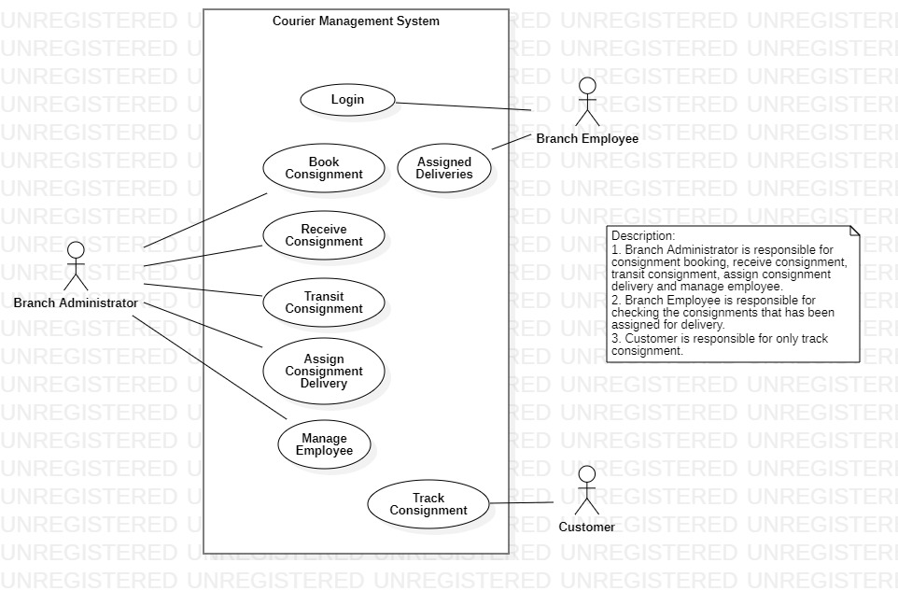

**SEQUENCE DIAGRAM FOR ATM MONEY WITHDRAWAL:**

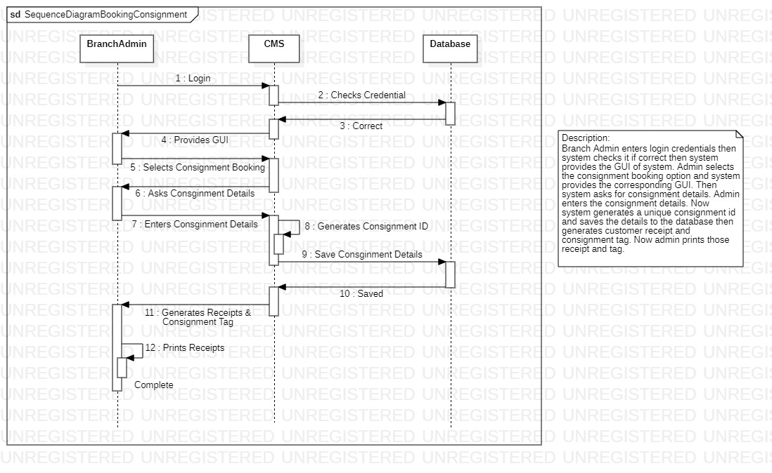

**ACTIVITY DIAGRAM FOR ATM MONEY WITHDRAW:**

